

**University of Computer Studies, Yangon**

**2018-2019 Academic Year**

**Third Year (CS)**

**Term Paper Report**

In Partial Fulfillment of the Requirement for CS-306 Term Paper

Ethical Copy-Writing

**Submitted by**

**3CS-64: Ma NweNiOoWai**

30August 2019

**Contents**

**Chapters Titles Page No.**

**Chapter 1 Introduction 1**

**Chapter 2 Background Theory**  1

2.1 Basic Concept of Copywriting 1

2.2 History and Evolution of copywriting 1

2.3 Basic Copywriting principle 2

**Chapter 3 The current situation of Ethical Copywriting**

3.1 The current situation of copywriting 3

3.2 Ethical copywriting 4

**Chapter 4 Future of Copywriting**

4.1 Future of copywriting 4

4.2 Ready-make technology tools for copywriters 5

**Chapter 5 Conclusion 5**

**Reference**  5

**List of Figures Page No.**

Figure 2.21 1

Figure 2.22 2

Figure 2.23 2

Figure 2.24 2

Figure 3.1 3

**Chapter 1**

**Introduction**

Copywriting is the process of writing advertising promotional materials. Copywriters are responsible for the text on brochures, billboards, websites, emails, advertisements, catalogs, tagline and more. Copywriting is important not only in field marketing but also digital marketing. In 2019, the average cost for website copywriting services is $25 to $25,000 per page. The aim of copywriting is to bring the product or service that can offer to the attention of the intended market. Nowadays, copywriter is professional career for digital marketing community.

**Chapter 2**

**Background Theory**

2.1 Basic Concept of Copywriting

Copywriting is the most attractive way to promote the products. Ethically copywriting is essential for promoting the products. Katy_the copywriter, reveals some of the basic concept to understand the copywriting.

1. Always empower customers to make an informed decision
2. Always answer questions and alleviate worries along the way
3. Always offer options for customers with different budgets
4. Always use inclusive and empowering language
5. Always credit direct sources of information and photography
6. Always solve problems, make people feel good, or do the world a favor

Based on my internship experience, these are the ways to create a balance marketing strategy between clients and marketing company.

2.2 History and Evolution of copywriting

Figure2.21John Emory Powers, first professional copywriter

There is a certain level of peculiarity that comes with being a copywriter that goes beyond simply being a writer or working in marketing. Advertising copywriting has existed since Babylonian times and the first printed material is said to have come into the world in 1477, promoting the sale of a prayer book. The history of copywriting dates back to when the first printed papers were distributed on the street. The actual word “copywriting” means the act of writing words to sell products. The copywriter is the person who does this, often found in ad agencies or at home as a freelancer.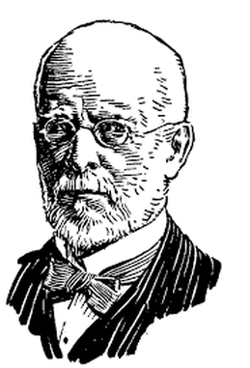

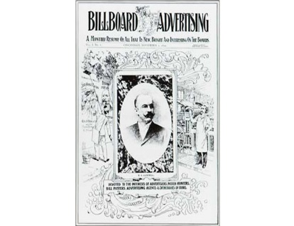Create an advertising Billboard and Pamphlets Figure 2.22 billboard ad

The job of a copywriter began by creating ads on a large poster made of paper with a feather dipped ink. These posters were fixed to walls and poles in the bigger cities of Europe. Centuries ago there were no printing processes to make duplicates, so each page was painstakingly handcrafted.

Figure 2.23 pamphlets

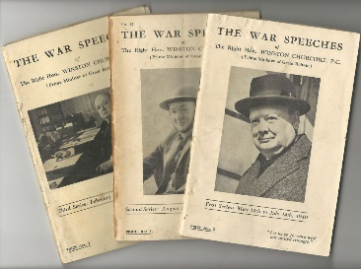

They evolved to printed pamphlets and brochures and became much smaller in size as printing in its new evolution was a complicated and lengthy process, so the smaller the item, the faster it was.

Figure 2.24 The oxford gazette

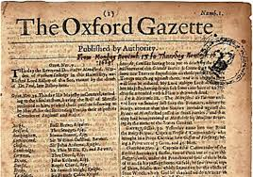Once mass printing processes were perfected, around 1605, newspapers could be mass produced and hawked on street corners. The first English paper was produced in 1664, called the [Oxford Gazette](https://www.thegazette.co.uk/history) (now known as the London Gazette). It was when the larger format newspapers were published that advertisements began to appear on one full page or several ads were dispersed throughout the pages.

2.3 Basic Copywriting principle

Copywriters generally use one of the following methods of copywriting to demonstrate these effectively:

* AIDA
* You vs We
* WAYS

## AIDA

Dating back to the 1920s, AIDA is one of the best known, most successful and oldest formulas for creating sales copy.

AIDA stands for:

* ATTENTION – any sales copy should attract the ATTENTION of the reader
* INTEREST – it should then arouse INTEREST in the product or service
* DESIRE – the copy should then stimulate a DESIRE to purchase
* ACTION – finally, and possibly most importantly, it should prompt ACTION from the reader

**You Vs We**

Good copywriters will always focus on what benefits YOU will enjoy as the purchaser, not what features WE, as the company, are providing.

## WAYS

This is the least well-known of the copywriting principles explained here. Its basic premise is that copywriters should **W**rite **A**s **Y**ou **S**peak.

**Chapter 3**

**The current situation of Ethical Copywriting**

3.1 The current situation of copywriting

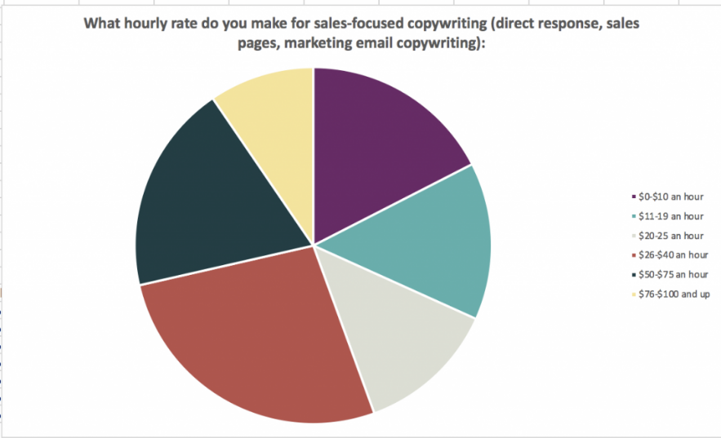

Figure 3.1 copywriting freelancer survey for 2019

Today’s modern copywriter does more than simply write copy for newspaper or magazine ads. With ecommerce growing at a rate of at least seventeen per cent per year and content marketing becoming a universal marketing tactic employed by ninety per cent of businesses worldwide, a copywriter now has to be proficient in writing for the web with a sound knowledge. Copywriters may also write copy for book jackets, food and product packaging, name floral bouquets, write about technology trends in healthcare, write meta data descriptions for sunglasses, write media releases about musicians and authors and so on. So, the copywriter should concentrate on:

* keeping it simple
* giving the facts needed to make an informed decision
* keeping the prospect’s question ‘What’s in it for me?’ in mind
* showing the benefits
* engaging his emotions
* creating an image in the prospect’s mind
* addressing his concerns

3.2 Ethical Copywriting

Nowadays, copywriting is used for every social media platform so that ethics of copywriting are significant to create principled and noble marketing society. These are

* Build a level of trust with client
* Secure clients’ confidential information
* Create news, not duplicate issues
* Treat with respect
* Don’t make promises you cannot keep, or make predictions without reasonable basis
* Make sure the details you give about the product is correct AND current
* Do research the facts and don’t guess the facts
* **Be clear about the services you provide**
* **Don’t promise stuff you can’t deliver**
* **Don’t sell clients stuff they don’t need.**

**Chapter4**

**Future of Copywriting**

4.1 Future of Copywriting

At the start of the millennium, digital was a miniscule part of marketing budgets. As online channels have increased its user base and engagement, digital marketing has become an essential tool for offline and ecommerce businesses. The online marketing space is only growing: in 2014, [businesses allocated 29 percent of marketing budgets to online](https://www.webstrategiesinc.com/blog/how-much-budget-for-online-marketing-in-2014). In 2018, that figure was 42 percent, and is expected to rise to 45 percent by 2020.

4.2 Ready-make technology tools for copywriters

As technology has changed what copywriting looks like, technology has also produced new tools to make its production easier. Writers can analyze their text through apps like ‘[Hemingway](http://www.hemingwayapp.com/)’ and ‘[Grammarly](https://www.grammarly.com/?q=brand&utm_source=google&utm_medium=cpc&utm_campaign=brand_f1&utm_content=76996511046&utm_term=grammarly&matchtype=e&placement=&network=g&gclid=EAIaIQobChMI6L-UkZ-M3wIVDsZkCh2FXw-jEAAYASAAEgKa3fD_BwE)’, which spot grammar mistakes and pinpoint those pesky run-on sentences or complex phrases.

Marketers also have new tools to help develop a content strategy. ‘[Buzzsumo](https://buzzsumo.com/)’ helps to identify the top-performing content in certain industries. Specifically, this app shows the number of social shares for any content, as well as backlinks to the pages. By looking at what's working for the competition, brands can develop a game plan for getting their message out across channels.

**Chapter 5**

**Conclusion**

Copywriting is not related with how many degrees you have and how old you are. It is creative writing that can express how you can promote your products. As my internship experience, copywriters need to connect with the whole marketing team, like designers, customer services, account, researchers and web front-end development teams. Moreover, they should create simple and short, and smooth tagline to remember the product, give advice to create Ads storyboard and write principled and fluent website translation. Copywriters need to learn a lot of knowledge, open-minded and creative thinking when they promote the products.

**References**

<https://www.scripted.com/content-marketing/technology-changing-future-copywriting>

<https://www.writersbureau.com/writing/copywriting-principles-explained.htm>

<https://medium.com/@joneswriter/the-history-and-evolution-of-copywriting-2f3c728e69dd>

<https://www.awai.com/what-is-copywriting/>

<https://melirvine.com.au/2018/11/10/ethics-for-copywriters-part-2-of-3-snake-oil-misleading-copy-and-duplicate-text/>

<https://www.melottimedia.com.au/blog/the-ethics-of-commercial-copywriting>